**ASSIGNMNENT 2(CORE HTML)**

1. **Build a simple webpage that displays text as shown in the below image.**

<!DOCTYPE html>

<html lang="en">

<head>

    <meta charset="UTF-8">

    <meta name="viewport" content="width=device-width, initial-scale=1.0">

    <title>Document</title>

</head>

<body>

    <p><b> This text will be bolded. </b></p>

    <p><i> This text will be italic. </i></p>

    <p><ins> This text will be underlined</ins></p>

   <mark> This text will be highlighted </mark>

   <p>This is normal text<sup> This will be super scripted </sup> This is normal again</p>

    <p>This is normal text <sub> This text will be subscripted </sub></p>

    <p>Normal Text <small> Smal Text </small></p>

    <p><del> This text will be deleted</del></p>

</body>

</html>

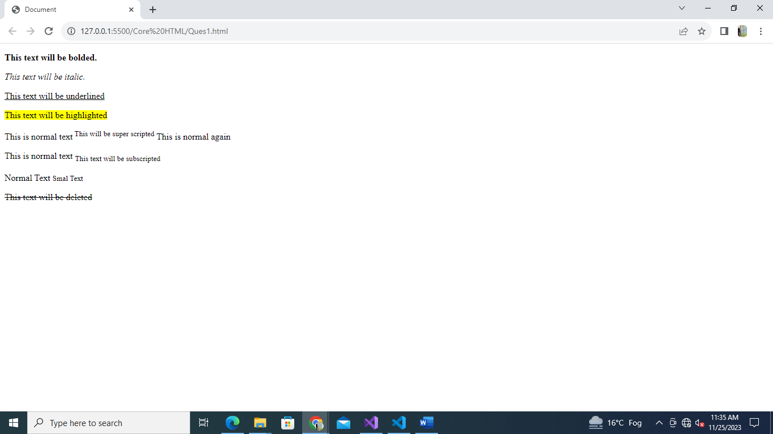**OUTPUT: -**

1. **Build a simple webpage that helps users navigate different web development-related websites.**

**Note: On clicking the hyperlink, the web pages should open in a new tab.**

<!DOCTYPE html>

<html lang="en">

<head>

    <meta charset="UTF-8">

    <meta name="viewport" content="width=device-width, initial-scale=1.0">

    <title>Document</title>

</head>

<body>

    <h1>Navigate Me:</h1>

    <p>Take me to

        <a href="https://pwskills.com/" target="_blank">PW Skills</a> to buy a course.

    </p>

    <p>Take me to

        <a href="https://developer.mozilla.org/en-US/" target="_blank">MDN docs</a>to know more about Web Development.

    </p>

    <p>Take me to

        <a href="https://lab.pwskills.com/" target="_blank">PW Skills Lab</a> to practice live coding.

    </p>

</body>

</html>

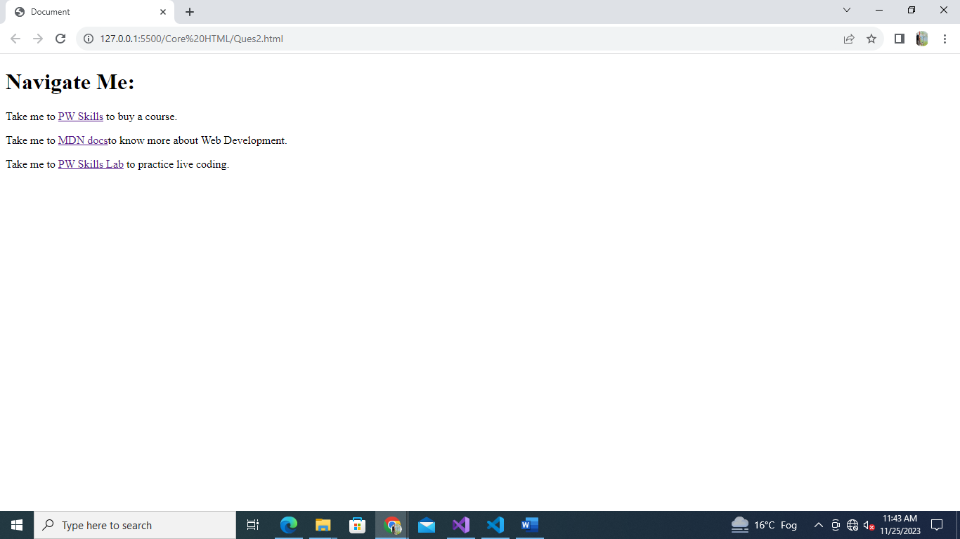**OUTPUT: -**

1. **Build a simple blog web page with 3 pages home, web development and web design. Each page must contain hyperlinks to other pages in the top, a heading of page topic and a paragraph of information. For the home page you can add some information about yourself.**

**Home.html**

<!DOCTYPE html>

<html lang="en">

<head>

    <meta charset="UTF-8">

    <meta name="viewport" content="width=device-width, initial-scale=1.0">

    <title>Document</title>

</head>

<body>

    <div>

        <a href="./home.html">HOME</a> |

        <a href="./webdevelopment.html">WEB DEVELOPEMENT</a> |

        <a href="./webdesign.html">WEB DESIGN</a>

    </div>

    <div>

        <h1>INTRODUCTION </h1>

        <p>I am <b>Mansi Srivastava</b>. I am basically from Uttar Pradesh. </p>

        <p>

        I had completed Master's in Computer Application from SRMS CET, Bareilly.

      I recently joined Physics Wallah in the Full Stack Web development course.

        </p>

        <p>

            My strength is self-motivated.

            My weakness is overthinking and I feel uncomfortable until my work will finish.

            My hobbies are I have the interest to learn something new, watching movies, and spending more time with family.

        </p>

        <p>

            My short-term goal is to attain the best position in the area of my work.

        </p>

    </div>

</body>

</html>

**Webdevelopement.html**

<!DOCTYPE html>

<html lang="en">

<head>

    <meta charset="UTF-8">

    <meta name="viewport" content="width=device-width, initial-scale=1.0">

    <title>Document</title>

</head>

<body>

    <div>

        <a href="./home.html">HOME</a> |

        <a href="./webdevelopment.html">WEB DEVELOPEMENT</a> |

        <a href="./webdesign.html">WEB DESIGN</a>

    </div>

    <div>

        <h1>WEB DEVELOPEMENT</h1>

        <p>

            <b>Web development</b>, also known as website development, refers to the tasks associated with creating,

            building, and maintaining websites

            and web applications that run online on a browser. It may, however, also include web design, web

            programming, and database management.

        </p>

        <p>

            The basic tools involved in web development are programming languages called HTML (Hypertext Markup

            Language), CSS (Cascading Style Sheets), and JavaScript.

            There are, however, a number of other programs used to “manage” or facilitate the construction of sites that

            would otherwise have to be done “from scratch” by writing code.

        </p>

    </div>

</body>

</html>

**Webdesign.html**

<!DOCTYPE html>

<html lang="en">

<head>

    <meta charset="UTF-8">

    <meta name="viewport" content="width=device-width, initial-scale=1.0">

    <title>Document</title>

</head>

<body>

    <div>

        <a href="./home.html">HOME</a> |

        <a href="./webdevelopment.html">WEB DEVELOPEMENT</a> |

        <a href="./webdesign.html">WEB DESIGN</a>

    </div>

    <div>

        <h1>WEB DESIGN</h1>

        <p>

            <b>Web design</b> refers to the design of websites. It usually refers to the user experience aspects of website development rather than software development. Web design used to be focused on designing websites for desktop browsers; however, since the mid-2010s, design for mobile and tablet browsers has become ever-increasingly important.

        </p>

        <p>

            A web designer works on a website's appearance, layout, and, in some cases, content.

        <ul>

        <li> Appearance relates to the colors, typography, and images used. </li>

            <li>Layout refers to how information is structured and categorized. A good web design is easy to use, aesthetically pleasing, and suits the user group and brand of the website. </li>

            <li> A well-designed website is simple and communicates clearly to avoid confusing users. It wins and

                fosters the

                target audience's trust, removing as many potential points of user frustration as possible. </li>

        </ul>

        </p>

    </div>

</body>

</html>

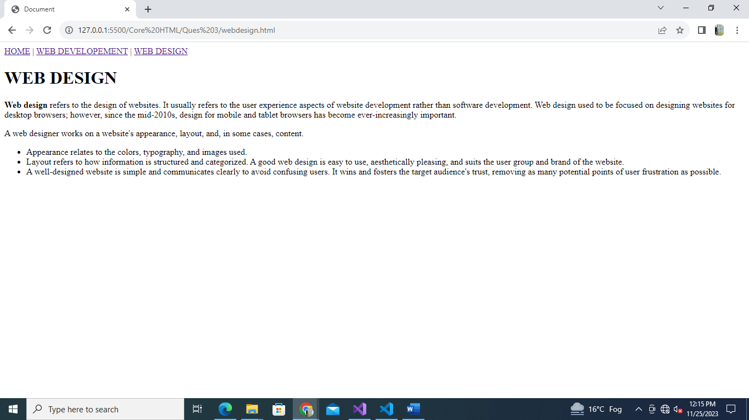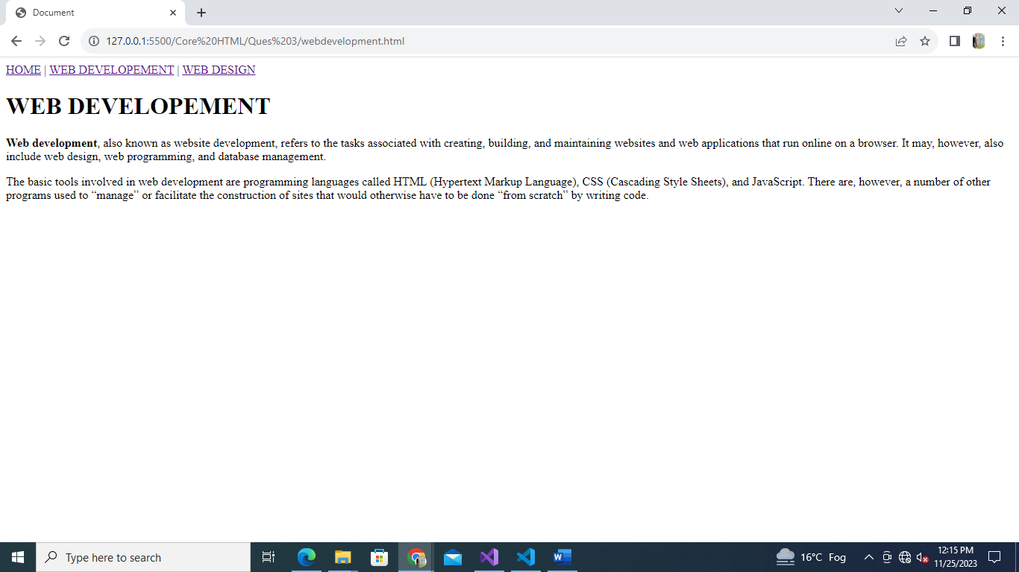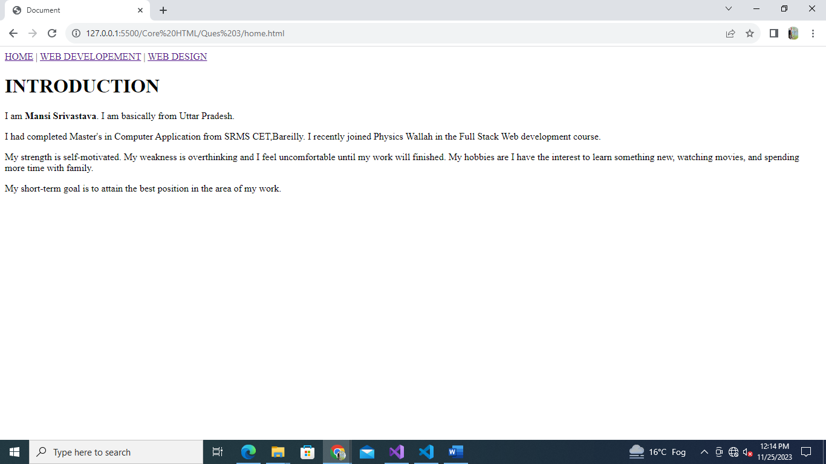**OUTPUT: -**

1. **Create an ordered list of HTML tags. Each list item must include the tag name and some information about tag.**

<!DOCTYPE html>

<html lang="en">

<head>

    <meta charset="UTF-8">

    <meta name="viewport" content="width=device-width, initial-scale=1.0">

    <title>HTMl Tags</title>

</head>

<body>

    <h1>List of HTML Tags</h1>

    <ol>

        <li><b>Heading (h1 to h6) :</b>A HTML heading or HTML h tag can be defined as a title or a subtitle which you

            want to display on the webpage.There are six different HTML headings which are defined with the h1 to h6

            tags. </li>

        <li><b>Paragraph (p) :</b>HTML paragraph or HTML p tag is used to define a paragraph in a webpage. An HTML

            <b>p</b> tag indicates starting of new paragraph.</li>

        <li><b>Div Tag (div):</b> The HTML DIV tag is used to group the large section of HTML elements together.</li>

        <li><b>Table Tag (table) :</b>HTML table tag is used to display data in tabular form (row * column). There can

            be many columns in a row.</li>

        <li><b>Ordered List (ol) :</b>HTML Ordered List or Numbered List displays elements in numbered format. The HTML

            ol tag is used for ordered list. </li>

        <li><b>Unordered Tag (ul) :</b>HTML Unordered List or Bulleted List displays elements in bulleted format . The

            HTML ul tag is used for the unordered list.</li>

        <li><b>Italic Tag (i) :</b>HTML <b>b</b> tag is used to display the written text in bold format. It is strictly

            a presentational element.</li>

        <li><b>Underline Tag (u)</b>HTML <b>U</b>> tag is used to define a span of inline text with a non-textual

            annotation. It rendered as an solid underlined text.</li>

    </ol>

</body>

</html>

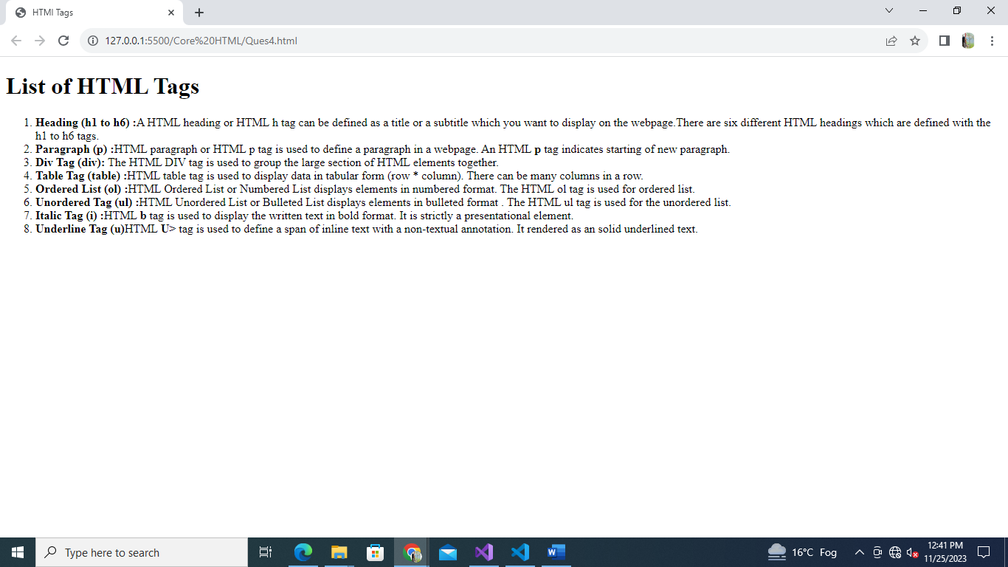**OUTPUT: -**

1. **Create a description list of full stack web development tech stack, using <dl> tag. Each term should be a tech stack name and each description should be a brief explanation of what the tech stack is used for.**

<!DOCTYPE html>

<html lang="en">

<head>

    <meta charset="UTF-8">

    <meta name="viewport" content="width=device-width, initial-scale=1.0">

    <title>List of Tech Stack</title>

</head>

<body>

    <h1>List of Full Stack Web Development Tech Stack:</h1>

    <dl>

        <dt>HTML</dt>

        <dd>

            HyperText Markup Language is the standard markup language for creating web pages and other online documents.

            HTML describes the structure of a Web page.

            HTML consists of a series of elements.

            HTML elements tell the browser how to display the content.

            HTML elements label pieces of content such as "this is a heading", "this is a paragraph", "this is a link",

            etc.

        </dd>

        <dt>CSS</dt>

        <dd>

            Cascading Style Sheets is a style sheet language used for describing the presentation of a document written

            in HTML or XML.

            CSS describes how HTML elements are to be displayed on screen, paper, or in other media.

            CSS saves a lot of work. It can control the layout of multiple web pages all at once.

        </dd>

        <dt>JavaScript</dt>

        <dd>

            JavaScript is the Programming Language for the Web.JavaScript can update and change both HTML and CSS.

            JavaScript can calculate, manipulate and validate data.

        </dd>

        <dt>Node.js</dt>

        <dd>

            Node.js is an open-source, cross-platform, JavaScript runtime environment that executes JavaScript code

            outside of a browser.Node.js runs on various platforms (Windows, Linux, Unix, Mac OS X, etc.).

            Node.js uses JavaScript on the server.

        </dd>

        <dt>Express.js</dt>

        <dd>

            Express.js is a small framework that works on top of Node.js web server functionality to simplify its APIs

            and add helpful new features. It makes it easier to organize your application’s functionality with

            middleware and routing. It adds helpful utilities to Node.js HTTP objects and facilitates the rendering of

            dynamic HTTP objects.

        </dd>

        <dt>MongoDB</dt>

        <dd>

            MongoDB stores data in flexible, JSON-like documents, meaning fields can vary from document to document and

            data structure can be changed over time.

            The document model maps to the objects in your application code, making data easy to work with

        </dd>

        <dt>React.js</dt>

        <dd>

            React.js is a JavaScript library for building user interfaces or UI components. React is used to build

            single-page applications.

            React allows us to create reusable UI components.

        </dd>

    </dl>

</body>

</html>

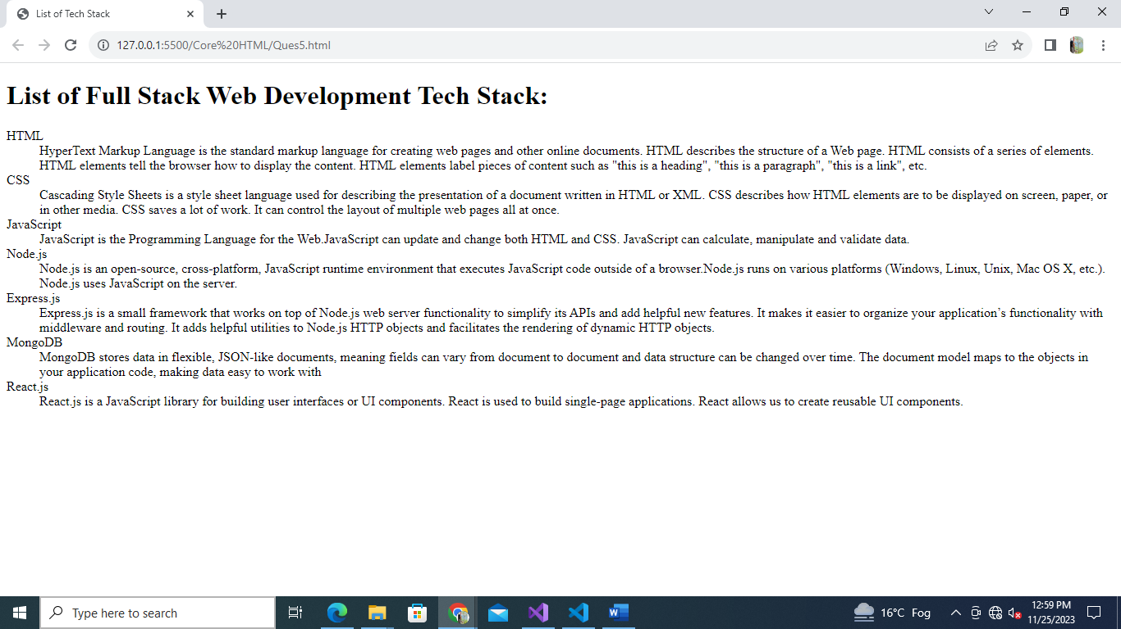**OUTPUT:-**

1. **Create an ordered list of the full stack web development tech stack HTML, CSS and JS. For each tech stack, create a table that lists the tech stack name, its primary use cases, and some key features or benefits.**

<!DOCTYPE html>

<html lang="en">

<head>

    <meta charset="UTF-8">

    <meta name="viewport" content="width=device-width, initial-scale=1.0">

    <title>Document</title>

</head>

<body>

    <ol>

        <li>

            <h2>HTML</h2>

            <table border="1">

                <tr>

                    <th>Primary Use Cases</th>

                    <th>Key Features/Benefits</th>

                </tr>

                <tr>

                    <td>

                        <ul>

                            <li>Building the structure of web pages.</li>

                            <li>Internet navigation.</li>

                        li>Offline capabilities usage.</li>

                        </ul>

                    </td>

                    <td>

                        <ul>

                            <li>It is easy to learn and easy to use.</li>

                            <li>It is platform-independent.</li>

                            <li>Semantic Structure.</li>

                        </ul>

                    </td>

                </tr>

            </table>

        </li>

        <li>

            <h2>CSS</h2>

            <table border="1">

                <tr>

                    <th>Primary Use Cases</th>

                    <th>Key Features/Benefits</th>

                </tr>

                <tr>

                    <td>

                        <ul>

                            <li>Add unique styles to our HTML document.</li>

                        <li>Change the overall look and feel of our website.</li>

                        </ul>

                    </td>

                    <td>

                        <ul>

                   <li>Allows for separation of content and presentation.</li>

                            <li>Enables responsive design.</li>

                            <li>Offers a wide range of styling options.</li>

                        </ul>

                    </td>

                </tr>

            </table>

        </li>

        <li>

            <h2>JavaScript</h2>

            <table border="1">

                <tr>

                    <th>Primary Use Cases</th>

                    <th>Key Features/Benefits</th>

                </tr>

                <tr>

                    <td>

                        <ul>

                            <li>Add interactive behavior to web pages like zooming in and out or playing audio/video.</li>

                            <li>Building web servers and server-side applications using Node.js.</li>

                   <li>Create games that operate inside the browser.</li>

                        </ul>

                    </td>

                    <td>

                        <ul>

                            <li>JavaScript is light Weight Scripting language.</li>

                            <li>JavaScript is platform-independent or we can say it is portable.</li>

                            <li>JavaScript is a prototype-based scripting Language.</li>

                            <li>Offers a wide range of functionality through libraries and frameworks.</li>

                         <li>Allows for server-side scripting with Node.js.</li>

                        </ul>

                    </td>

                </tr>

            </table>

        </li>

    </ol>

</body>

</html>

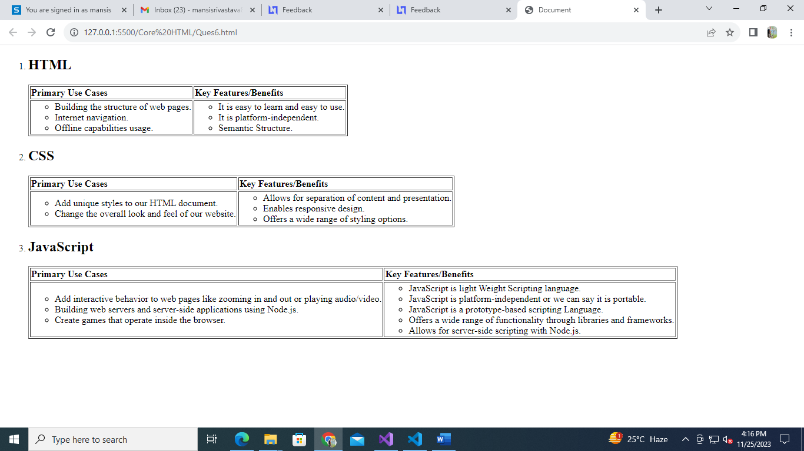**OUTPUT: -**

1. **Build a complex nested list structure representing a multi-level table of contents. Use unordered lists (<ul>) and list items (<li>) with inline-block styling to create a structured layout. A enhance the presentation of list items.**

<!DOCTYPE html>

<html lang="en">

<head>

    <meta charset="UTF-8">

    <meta name="viewport" content="width=device-width, initial-scale=1.0">

    <title>Document</title>

</head>

<body>

    <h1>Table of Contents</h1>

    <ul>

        <li><a href="#">Part 1: Introduction</a></li>

        <li><a href="#">Part 2: Getting Started</a>

            <ul>

                <li><a href="#">2.1 Installing the Software</a></li>

                <li><a href="#">2.2 Creating a New Project</a>

                    <ul>

                        <li><a href="#">2.2.1 Project Templates</a></li>

                        <li><a href="#">2.2.2 Customizing Settings</a></li>

                    </ul>

                </li>

                <li><a href="#">2.3 Exploring the Interface</a>

                    <ul>

                        <li><a href="#">2.3.1 Toolbar Features</a></li>

                        <li><a href="#">2.3.2 Panel Layout</a>

                            <ul>

                                <li><a href="#">2.3.2.1 Docking Panels</a></li>

                                <li><a href="#">2.3.2.2 Tabbed Interface</a></li>

                            </ul>

                        </li>

                    </ul>

                </li>

            </ul>

        </li>

        <li><a href="#">Part 3: Advanced Topics</a>

            <ul>

                <li><a href="#">3.1 Working with Plugins</a>

                    <ul>

                        <li><a href="#">3.1.1 Installing Plugins</a></li>

                        <li><a href="#">3.1.2 Plugin Configuration</a></li>

                    </ul>

                </li>

                <li><a href="#">3.2 Customizing the UI</a>

                    <ul>

                        <li><a href="#">3.2.1 Changing Themes</a></li>

                        <li><a href="#">3.2.2 Configuring Shortcuts</a></li>

                    </ul>

                </li>

                <li><a href="#">3.3 Optimizing Performance</a>

                    <ul>

                        <li><a href="#">3.3.1 Caching Strategies</a></li>

                        <li><a href="#">3.3.2 Resource Minification</a></li>

                    </ul>

                </li>

            </ul>

        </li>

        <li><a href="#">Part 7: Conclusion</a></li>

    </ul>

</body>

</html>

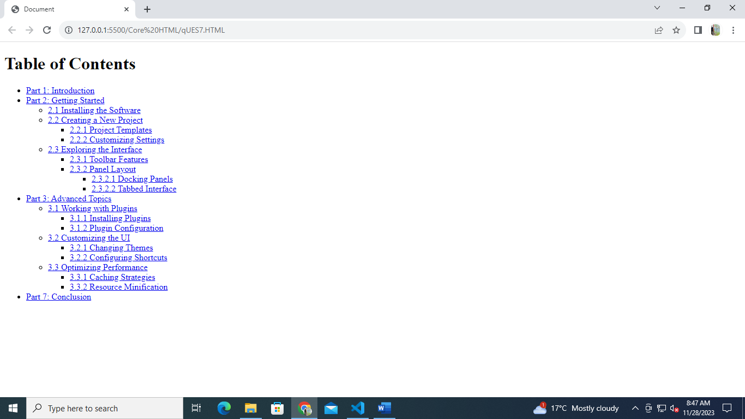**OUTPUT: -**

1. **Create a table to display a conference schedule. Each row corresponds to a time slot, and each column corresponds to a room. Some times slots might have multiple sessions running simultaneously in different rooms. Utilize rowspan and colspan attributes as necessary to accommodate this complex schedule.**

**(use table attribute “cell padding” to give extra padding in each table cell).**

<!DOCTYPE html>

<html lang="en">

<head>

    <meta charset="UTF-8">

    <meta name="viewport" content="width=device-width, initial-scale=1.0">

    <title>Question 8</title>

</head>

<body>

    <h1>Conference Schedule</h1>

    <table border="1" cellpadding="10">

        <thead>

            <tr>

                <th>Time</th>

                <th>Room 1</th>

                <th>Room 2</th>

                <th>Room 3</th>

                <th>Room 4</th>

            </tr>

        </thead>

        <tbody>

            <tr>

                <td rowspan="3">9:00 AM - 10:00 AM</td>

                <td rowspan="2">Keynote</td>

                <td>Session A</td>

                <td>Session B</td>

                <td rowspan="3">Session C</td>

            </tr>

            <tr>

                <td>Session D</td>

                <td>Session E</td>

            </tr>

            <tr>

                <td>10:30 AM - 11:30 AM</td>

                <td colspan="2">Session F</td>

            </tr>

            <tr>

                <td>12:00 PM - 1:00 PM</td>

                <td colspan="4">Lunch Break</td>

            </tr>

            <tr>

                <td rowspan="2">1:00 PM - 2:00 PM</td>

                <td>Session G</td>

                <td rowspan="2">Session H</td>

                <td>Session I</td>

                <td>Session J</td>

            </tr>

            <tr>

                <td>Session K</td>

                <td>Session L</td>

                <td>Session M</td>

            </tr>

        </tbody>

    </table>

</body>

</html>

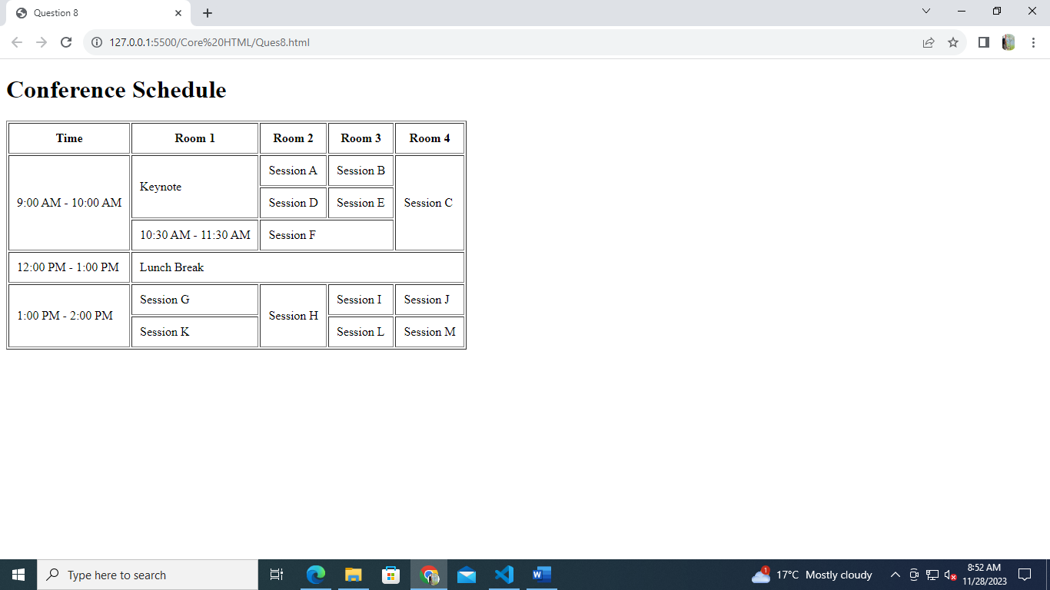**OUTPUT: -**